Portable Device for Ultraviolet Sanitation of Water
Joseph S. Wahlen, Sannidiyan M. Rajendran, Raymond Masciarella, Damian LaRocque
Depts. of Electrical Engineering, Computer Science and Photonic Science, University of Central Florida, Orlando, Florida, 32816-2450

Abstract — Ultraviolet light applications have seen an explosion in use since the beginning of the COVID-19 pandemic. Short wavelength ultraviolet radiation in the UVC wavelength regime (200~280 nm) has also been shown to be extremely potent in neutralizing water borne pathogens and coliforms. This paper will focus specifically on the application of these UVC wavelengths to waterborne pathogens at a scale not yet available in the public marketplace. The Portable Ultraviolet Water Sanitation device (PUVC) looks to take advantage of this through offering a modular, easy to use, portable device for effective and verifiable water sanitation far from a water treatment plant.

Index Terms — Germicidal, Portable, Sanitation, Ultraviolet, Water

I. Introduction
The use of sunlight as a form of sanitation dates back to the paleolithic era and perhaps even farther. While primitive humans did not understand the exact mechanics as to how the sunlight eliminated pathogens it did not stop them from using direct sunlight to “bathe” a variety of their daily tools, water, and food. It wasn't until 1877 that the germicidal effect of light on microbial growth was scientifically investigated by Arthur Downs and T.P. Blunt [3]. The investigators found not only that shorter rays of sunlight prevented growth of bacteria in tubes containing Pasteur’s solution but that there was a provable relationship between the ability of the sunlight to sterilize the sample and the effective dose of sunlight the sample received. The dose of irradiation impinged upon a surface can be calculated using the simple equation shown below where I denotes the wavelength dependent intensity of the exposure and D denotes the duration of the exposure.

$UV Dose (J∙m^{-2}) =I (W∙m^{-2}) ∗D (s)$ (1)

Soon after Downs and Blunts discovery the first notable application of ultraviolet light as a germicidal agent was introduced by Neils Fensen in 1903. He used concentrated light radiation to treat Lupus Vulgaris with a very high recovery rate unseen before the advent of his techniques. Dr. Neils would go on to win a nobel prize in medicine for his work and in the years following his discovery allowed an entire new field of study to begin.
Ultraviolet light is now being used to sanitize surfaces, air, commercial drug products and countless other mediums. This paper will focus specifically on the application of UVC radiation to contaminated drinking and municipal water. Contaminated drinking water accounts for nearly 3.4 million global deaths annually. This statistic astounded the team and was the primary motivation for why the PUVC was created.
The method being used to eliminate the waterborne pathogens through the use of UVC radiation is called UV Germicidal Irradiation (UVGI). UVGI is a technique that utilizes UVC radiation to neutralize the coliform's ability to replicate (5). This works effectively to neutralize the DNA responsible for replication because the nucleic acids present inside the nucleus of most common coliforms such as E. Coli is highly absorptive to UVC wavelengths in the range of 254-275 nm (1). Shown below in Fig. 1 is the dosage of UVC required to kill most common coliforms.

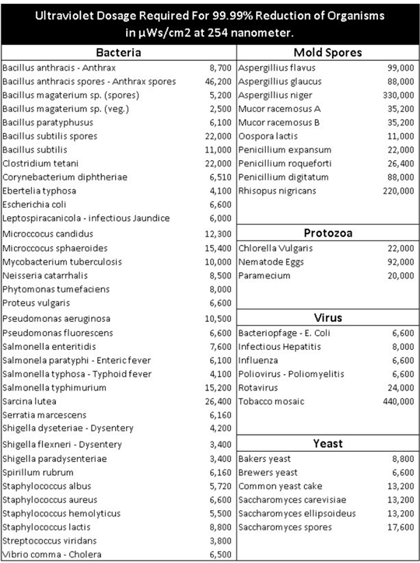
Fig. 1. Shown above is a chart provided by the EPA on dosage guidelines to neutralize common coliforms present in water supplies(6).

The Portable UVC cleaner is going to perform UVGI through three unique UVC emitting devices as well as provide a post processing optical and chemical analysis to verify there is no longer coliform present in the water. A user interface used to run the PUVC as well as the integrated electrical circuits of the machine will be discussed as well later in this paper. These devices and their structures will be further discussed in the following sections II and III.

II. Overview of PUVC Design
The PUVC will utilize several key technologies to ensure the appropriate sanitation of the waterborne coliforms. The four primary components of the design that will allow for effective use of the device are as follows.

- UV power delivery system
- Integrated electronic control circuit and solar charger
- Wifi connected user interface
- Optical coliform identification unit

The PUVC will be controlled by a user interface designed to display several key parameters to the user and allow for overall control of the device. The user interface will also allow the user to monitor the water sanitation process as well as provide key information regarding the optical coliform identification unit. An integrated electrical system that allows for solar charging of the battery and efficient use of the battery will allow the PUVC to operate without the use of a wall plug in. This is a key feature to allow the PUVC to truly impact those rural populations that require water sanitation. The charging as well as battery function will be further discussed in section IV. Shown below in Fig. 2 is a diagram explaining the basic flow of the device as well as which team member was responsible for each essential component.
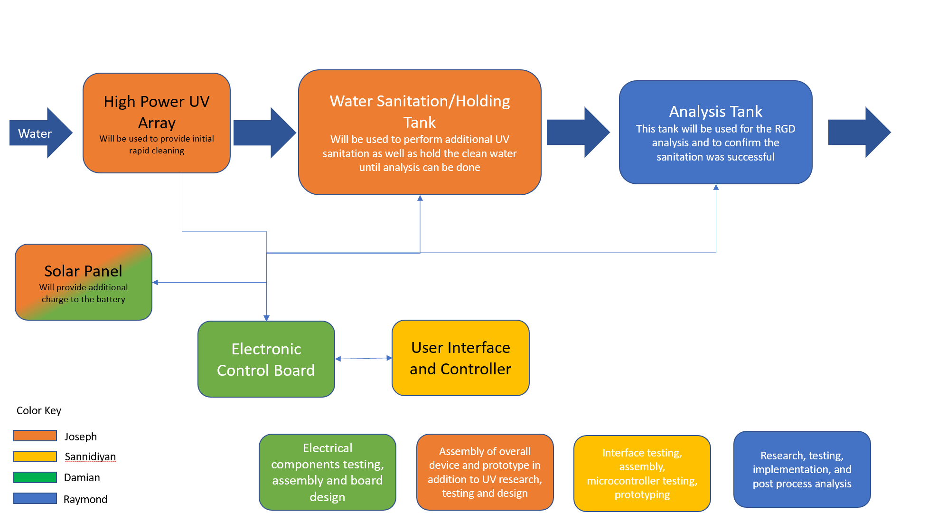
Fig. 2. Shown above is a block diagram of how the unit will systematically move the water through the system as well as the key components each team member was responsible for and their primary function.

As can be seen above the PUVC will work as follows. The PUVC will intake the water, pass it though a high power array with user controlled pumps, sanitize the water, hold the water in a sanitation tank, perform an analysis on the water post sanitation and finally dispense the water once it has been proven clean to consume. Due to the chemical nature of the coliform test used to identify the water this may take 24-48 hours. Once the test is performed though as long as the user does not change the water source or new contamination is introduced then the water would only have to be tested every two weeks or less. These are the same guidelines used in most United States municipal water treatment plants and set out by the EPA for coliform tainted water. We would like the reader to keep in mind the PUVC will have no effect on harmful metallics, robust chemical compounds, or oil and grease. Care must be taken to pre filter the water so that the dose of the UVC is not absorbed by contaminants other than the coliform. The following sections will detail each of the primary components of the design as well as the tests done to ensure the efficacy of the UVC dose.

III. UV Power Delivery Systems
The PUVC will employ three unique UVC sources to provide enough power to produce the UVGI effect mentioned earlier in the introduction section. These three arrays are listed below.

- High power LED Array
- Low power LED Lens Triplet Array
- Low pressure high power mercury UVC Lamp

Each of the devices listed above provides a unique output pattern as well as serves a specific sanitary purpose within the PUVC. Both the high power and low power LED arrays will use the same E-275 UVC LEDs. The output spectrum of several different LEDs from the high and low power array are shown below in Fig. 3. Using a spectrometer the team was able to verify that the center wavelength of the diodes was indeed close to the 275 nm required for effective cleaning. While it is not exactly at 275 nm this should not impact the germicidal efficacy as most coliforms are susceptible to wavelengths in the range of 245-350 nm (6). In Fig. 3 below one can also notice a distribution of intensity within the visible wavelength regime, these wavelengths will have no impact on the germicidal effect and will not interfere with the UVC efficacy therefore the team did not create an optical system to eliminate it.

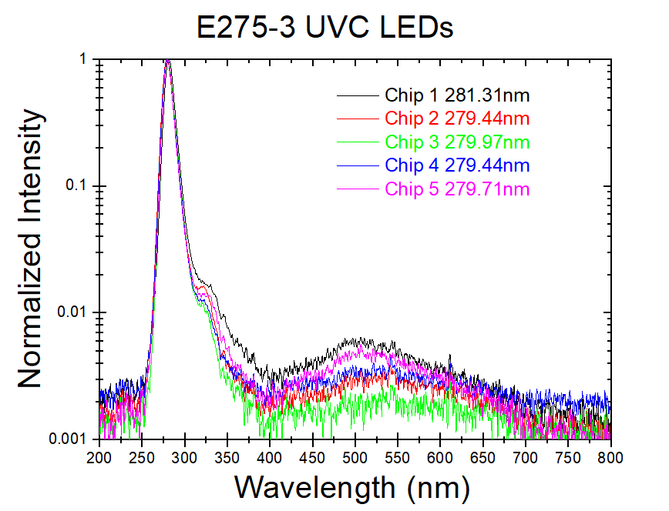
Fig. 3. Shown above is the output spectrum of 5 of the UVC LEDs used in the array.

The following Fig. 4 displays the difference in the respective intensity peaks of the previous 5 tested LEDs.

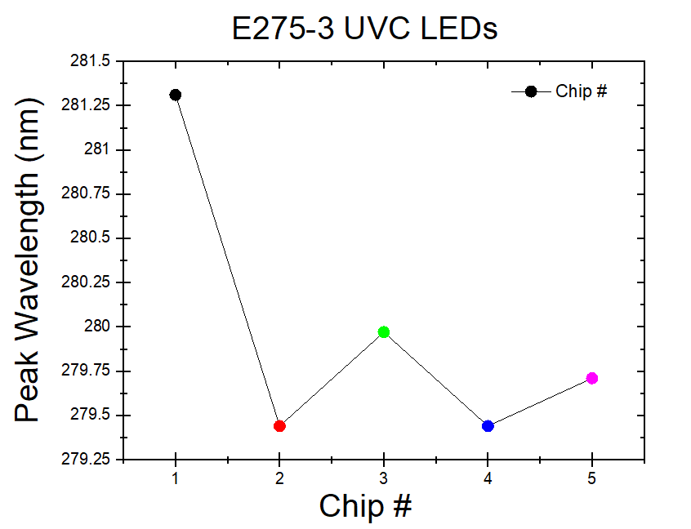
Fig. 4. Shown above is the center wavelength corresponding to peak intensity produced from the LEDs.

As can be seen above all 5 LEDs are very close in peak wavelength value. The LEDs were tested sequentially from 1 to 5, therefore due to a decreased temperature of the board we believe the LED #1 peak wavelength was pushed to a greater value. This is further displayed as the difference in the following 4 LEDs tested at a stabilized temperature were much closer in value. The following sections will detail all three power delivery arrays.

A. High Power LED Array
The high power LED array will provide an initial high power UV dose to the water as it passes between 10 E-275-3 UVC LEDs connected in series. Shown below in Fig. 5 is the completed design with one LED panel removed to show the orientation of the LEDs along the array. The numbers shown in the photo are to denote the LED in order from top to bottom. The second photo in Fig. 5 shows a vertical view of the array and red outlined dimensions. The array must be mounted vertically to properly sanitize the water. With the unit in a vertical position the water is able to completely fill the chamber dramatically reducing the turbidity of the water and allowing for greater penetration of the UVC wavelengths as there are no air pockets to disperse the rays.
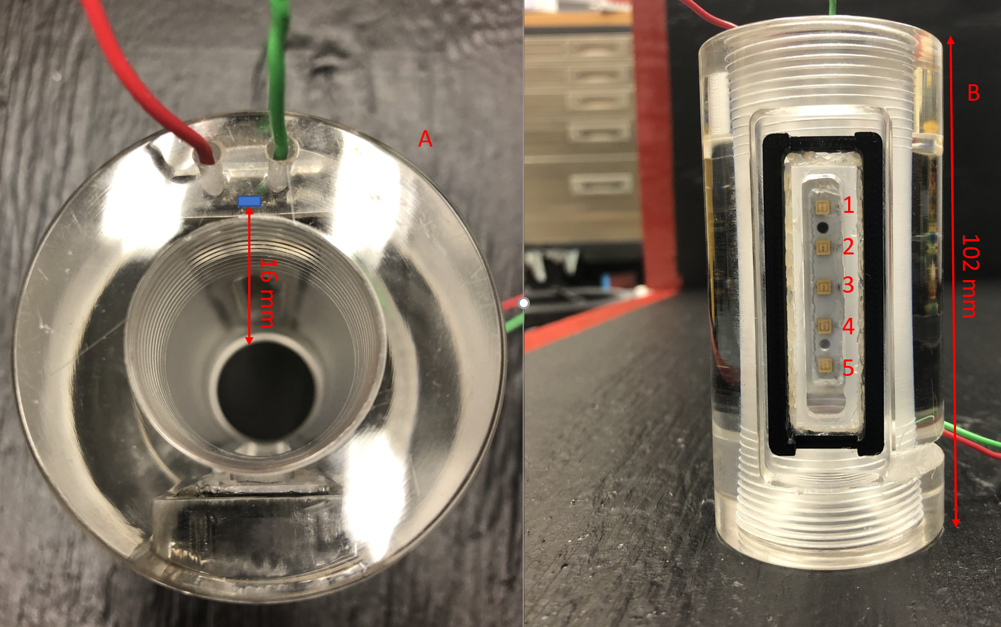
Fig. 5. Shown above is a top view of the array apparatus, the blue square denotes the LED and the red measurements denote distance to the array center. (B) Shown is a front view of the array numerically listing the LEDs.

We used this approximate radius of the array to test the power drop off of the LEDs as the distance from the LED approached a max of 16 mm. Shown below in Fig. 6 is the relation between distance and power of the LEDs inside the array. We would like the reader to keep in mind that these powers were taken through a quartz window to ensure the listed powers match as closely as possible to processing powers. The total power loss recorded from the quartz windows used on the arrays to protect the LEDs are on average 15.56%. This could be further reduced using anti-reflection coated windows.

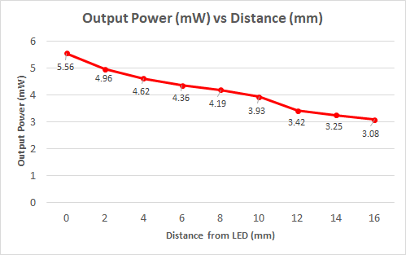
Fig. 6. Shown above is the output power vs distance of the LEDs used inside the array.

As can be shown above the power dropoff to the center is near 45%. This although significant still provides a great enough UV dose to perform sanitation. Shown below in Fig. 7 is the experimentally recorded output powers produced from the LED at various currents. The numerical listing of the LED corresponds to the numeric position of the LED shown in Fig. 5 above. The LED powers numbered 1-5 are averages of the two LEDs that are parallel in position. The LED total average is shown in green and is the average output of all 10 LEDs.

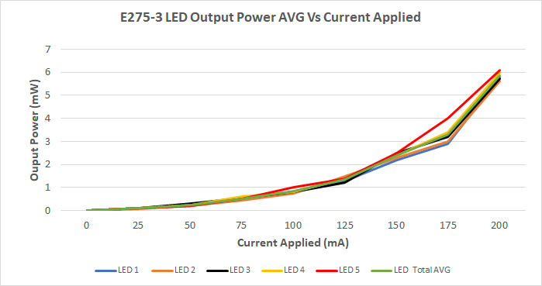
Fig. 7. Shown above is the E-275 LED output power vs current applied. The voltage was set to 12.42V as the current was modulated.

The team did note that as the LEDs were pushed towards their max power as the position of the LED vertically goes down the max power would seemingly increase. This is due to the experimental method used to take the output power measurements. As consecutive tests of the LEDs were done the panel holding them began to rise in temperature. This increase in temperature corresponded to an increase in the output powers towards the maximum power output rating of the LED at 6.0 mW. Due to the residual heat of the testing done before the last LEDs to be tested, LED 5, was shown to have the highest power. This is purely due to stabilization of power and was proved by the team with further testing.
To calculate the UV dose the team first needed to understand how long the water would be in the array before it moves to the sanitation tank. To get an estimate the team placed small styrofoam balls within the water stream to estimate the time of travel. With the time of travel estimated to be 3-5 seconds in the array a UV dose of 166.8 mJ$∙m^{-2}$ can be estimated.

B. Low Power LED Lens Triplet Array
The low power LED lens triplet array serves as an ambient cleaner to prevent coliform growth inside the tank. The ambient cleaner neutralizes any coliform that may be introduced to the tank after the water has passed the high power array. This can occur when the top of the tank is opened. The low power ambient array is composed of five E-275 UVC diodes. A custom 3D printed mount for the LEDs was designed and built for the tank as well as custom mounting for all three lenses. The lenses were aligned concentrically with the central LED in the mount.
The optical setup used for the experimental measurements is shown below in Fig. 8 as well as the LED array employed.The final optical array will maintain the distances shown in Fig. 8.

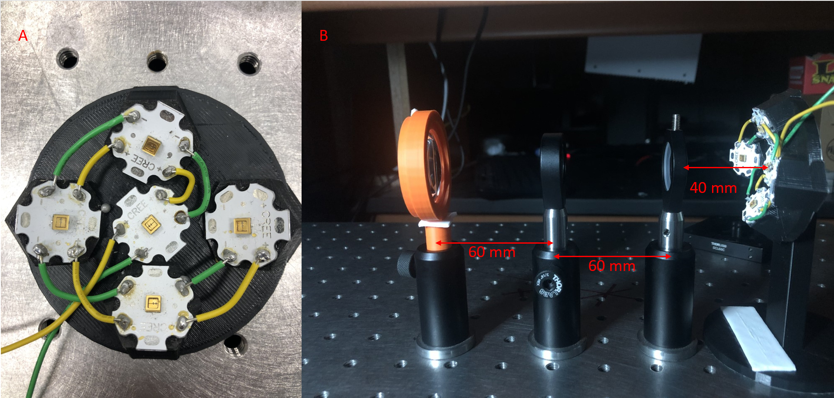
Fig. 8. Shown above is (A) the LED array to hold and aim the 5 LEDs used in the ambient array as well as (B) the optical setup and distances used to produce the output shown in Fig. 9.

To demonstrate how the LED light was redistributed a simple test was done to prove the collimation of the LEDs.
Shown below in Fig. 9 is a demonstration of the redistribution of the LED output pattern.

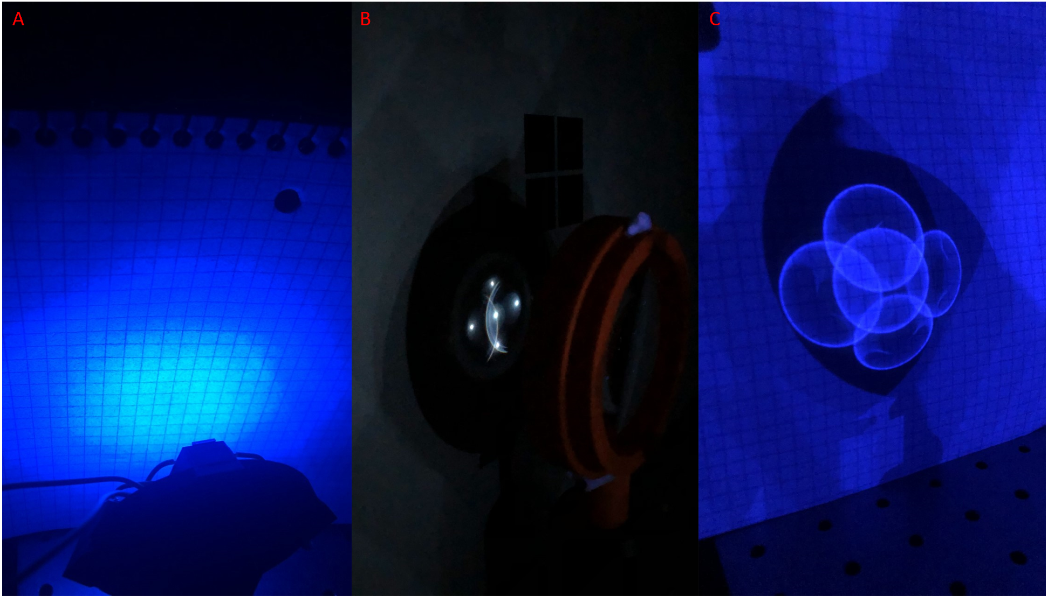
Fig. 9. Shown above is the collimation testing done for the low power array.(A) The output profile without any collimation at 5 cm from the array. (B) The output profile after the LEDs have been collimated and 5 cm from the final lens.(C) The output profile from the collimated LEDs at 25 cm.

With all these parameters set the UVC ambient array was able to produce a dose near 30 mJ$∙m^{-2}$ . This is significantly less than the high power array as the loss from the lenses and quartz window added together is near 80%. This is fine for the application as the array is simply used as an ambient cleaner and should not be capable of performing initial sanitation, only preventing new growth.

C. Low Pressure High Power Mercury Lamp
The high power UV-C producing lamp will serve as a backup when there is a greater power needed to clean the water of coliform. Once it has been determined by the verification system that the water is indeed still infected with coliform the device will then allow for the user to turn on the lamp and irradiate the water. The mercury lamp that was selected for the device is the Ster-L-Ray G18T5L-U (G18). The G18 has a total power output of 18.4 W. This power is not all in the UVC regime. The lamp when activated to produce UVC radiation will through the heating of the mercury output a wavelength range of 200 - 700 nm.We were unable to get a max power measurement of the device as doing so would oversaturate the power meters available to the team. To overcome this the team planned out with Atlantic Ultraviolet, the provider of the lamp, to ensure that testing could be done before the lamp was sent to us to guarantee the appropriate power requirements were met. Through their testing they were able to verify an overall power of 18.2 W from the device, 5.4 W$∙m^{-2}$ specifically in the UVC wavelength regime.
The team did expect this as the remaining power being emitted is in visible wavelength regime. The team determined taking a measurement of these powers would show no relation to the efficacy of the device and therefore it has been omitted from this paper. With this power and with a duration time of 10s the UV dose produce is 54 J$∙m^{-2}$ . This power is substantially greater than needed and can in fact be reduced by more than half and provide the same efficacy. The operation of the lamp and photos of the lamp in the chamber can be found in section V Fig. 10 and Fig. 11.

IV. Power System and Electronic Circuits
The PUVC is powered by a 12 V sealed lead-acid battery which can be recharged through either AC power sourced from a wall outlet or through solar panels. The battery has a capacity of 12 Amp-hours which allows for 3 operating hours per charge. The 30 W solar panel enables the PUVC to run a full cleaning cycle completely off of solar panel power in the right sunlight conditions. The battery’s charge control is maintained by a purchased 20 A PWM solar charge controller. The charge controller has a discharge current of 10 A which is more than enough to meet the requirements of the system’s components. It charges the battery at 1 A which is roughly 10 percent of the battery’s capacity which is ideal for preserving the life of the battery. The AC charge source and the solar panels are connected in parallel at the input of the charge controller, the lead-acid battery is connected in parallel with an inverter at the battery port of the charge controller and at the output of the charge controller is a regulated voltage of 12 V.
Connected to the 12 V output of the charge controller is a simple hand-soldered breakout board to allow for a 6 V DC-DC converter, a 5 V DC-DC converter and a 12 V LED array to connect to the 12 V output as well as the ATmega microcontroller board. The 5V and 6V DC-DC converter designs were obtained from TI Webench power designer and then the schematics were drawn up in EasyEDA. The 6 V regulator uses the TPS561208 converter while the 5 V regulator uses the TPS56628 converter, both of which are synchronous, switching, step-down regulator chips by Texas Instruments. The PCB layout was done according to the guidelines provided in the datasheets of the converters and then printed by JLCPCB. The parts were sourced from LCSC electronics and then hand-soldered onto the board. The 6 V DC-DC converter powers the 6 V LED array and the 5 V DC-DC converter powers the Raspberry Pi via USB port. The inverter was necessary to power the UV lamp which runs off of AC power.
The microcontroller used for reagent color sensing is the ATmega328P-PU. Once the color reading was tested and working on the arduino development board, a PCB which integrates the microcontroller and its connected components was designed. Using the open source schematics of the arduino, all components of the arduino being used for color sensing were included on the PCB and the unused components removed. The PCB includes a socket for the ATmega328P microcontroller, a 16MHz crystal oscillator, an RGB LED, a Cds photocell, some resistors and some capacitors. The board also has jumpers for the UART transmit and receive pins, the 5 V pin and the ground pin. These jumpers were made available so that the arduino could transmit its results to the Raspberry Pi via UART communication which is then used to determine whether the cleaning process was successful or not. The PCB design was done using EasyEDA and the PCB was printed by JLCPCB. The control circuit of the system is the Raspberry Pi. The Raspberry Pi toggles the LEDs and water pumps through a relay board which connects to the components that need to be toggled as well as the GPIO pins of the Raspberry Pi.

V. Software design and implementation
With the development of the PUVC, the system will need to be both monitored and controlled. For this use case, it can be done with a Raspberry Pi. The Raspberry Pi will be used in numerous ways: gather information via sensors, host a user interface (UI) to monitor and control the system, and be used as an access point if no prior WiFi connection exists.

A. Sensor Integration

There were two sensors used to monitor the system.

- Arducam (Raspberry Pi Camera Module)
- BME280 (Temperature, Humidity, and Pressure)

The first sensor plugged directly into the Pi, allowing the Pi to easily interface and extract visual, picture data. The second utilized the available GPIO pins to communicate via I2C.
For each sensor attached, the Python Raspberry Pi library (RPi) can be used to efficiently and effectively communicate with the device(s). For this use case, numerous other python libraries were used: picamera, http, socketserver, and the adafruit_bme280. As mentioned prior the BME280 communicates via I2C on 0x76 and can easily be accessed via the adafruit library. The Python script developed to extract those values simply outputs the value to the console which will then be used in tandem with a web server to display the data. The access of the arducam proved more difficult. An open source Python script was found utilizing picamera, http, and socketserver libraries allowing the script to host a server, constantly sending input to localhost:8200/. This allows the hosted user interface (UI), which will be discussed below, to simply embed that video stream within the web UI.

B. Access Point, Server, and User Interface

Given the requirements that the system must be able to operate in a potentially remote location, it can be justified that an internet connection will not be accessible. To combat this, the Raspberry Pi can be transformed into an Access Point (AP) in order to host PUVC related services. Using the two libraries, hostapd and dnsmasq, the Raspberry Pi can easily be turned into an AP. Hostapd utilizes the Raspberry Pi’s network card to act as an access point. From there, dnsmasq can be used as a Domain Name System (DNS) and properly forward packets to correct locations. These two libraries allow the Raspberry Pi to operate in areas without an existing network.
The Raspberry Pi will also host a Node.js and Express.js server to serve and push data to the frontend. Node.js was chosen due to it’s open source package framework, utilizing node package manager (npm) to utilize many community built packages. It also allows the entire stack to be built from javascript, with the frontend being React.js which will be talked about below. Node.js utilizes Express.js for routing and resource retrieval to serve the proper pages. The server will also include endpoints to run Python script(s) to extract sensor information, package, and return the information to the client.
As mentioned prior, the frontend was written and developed using React.js. React.js is a component based architecture to create a virtual DOM. The page served is rendered on a component-level instead of re-rendering the entire page, saving computation time and CPU resources. This allows the Raspberry Pi to save potentially important CPU cycles for other system processes.

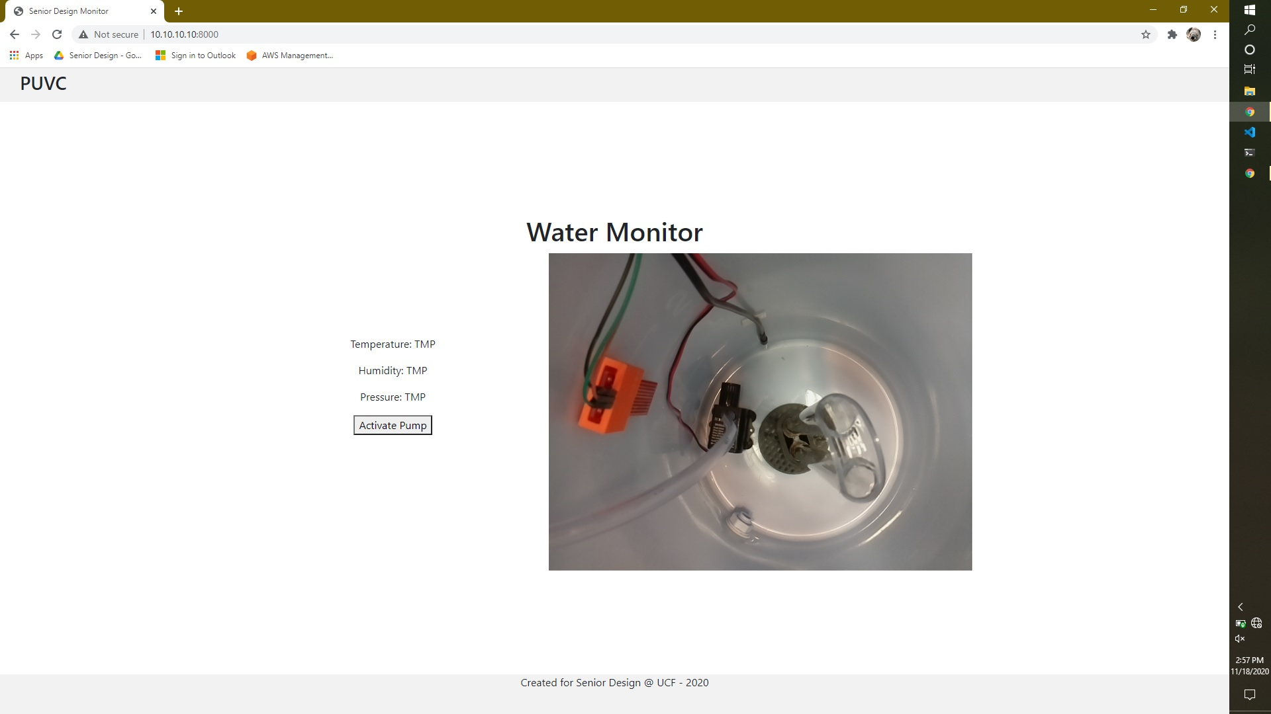
Fig. 10. Shown above is the UI used to monitor and control the system. Here the UV lamp is off.

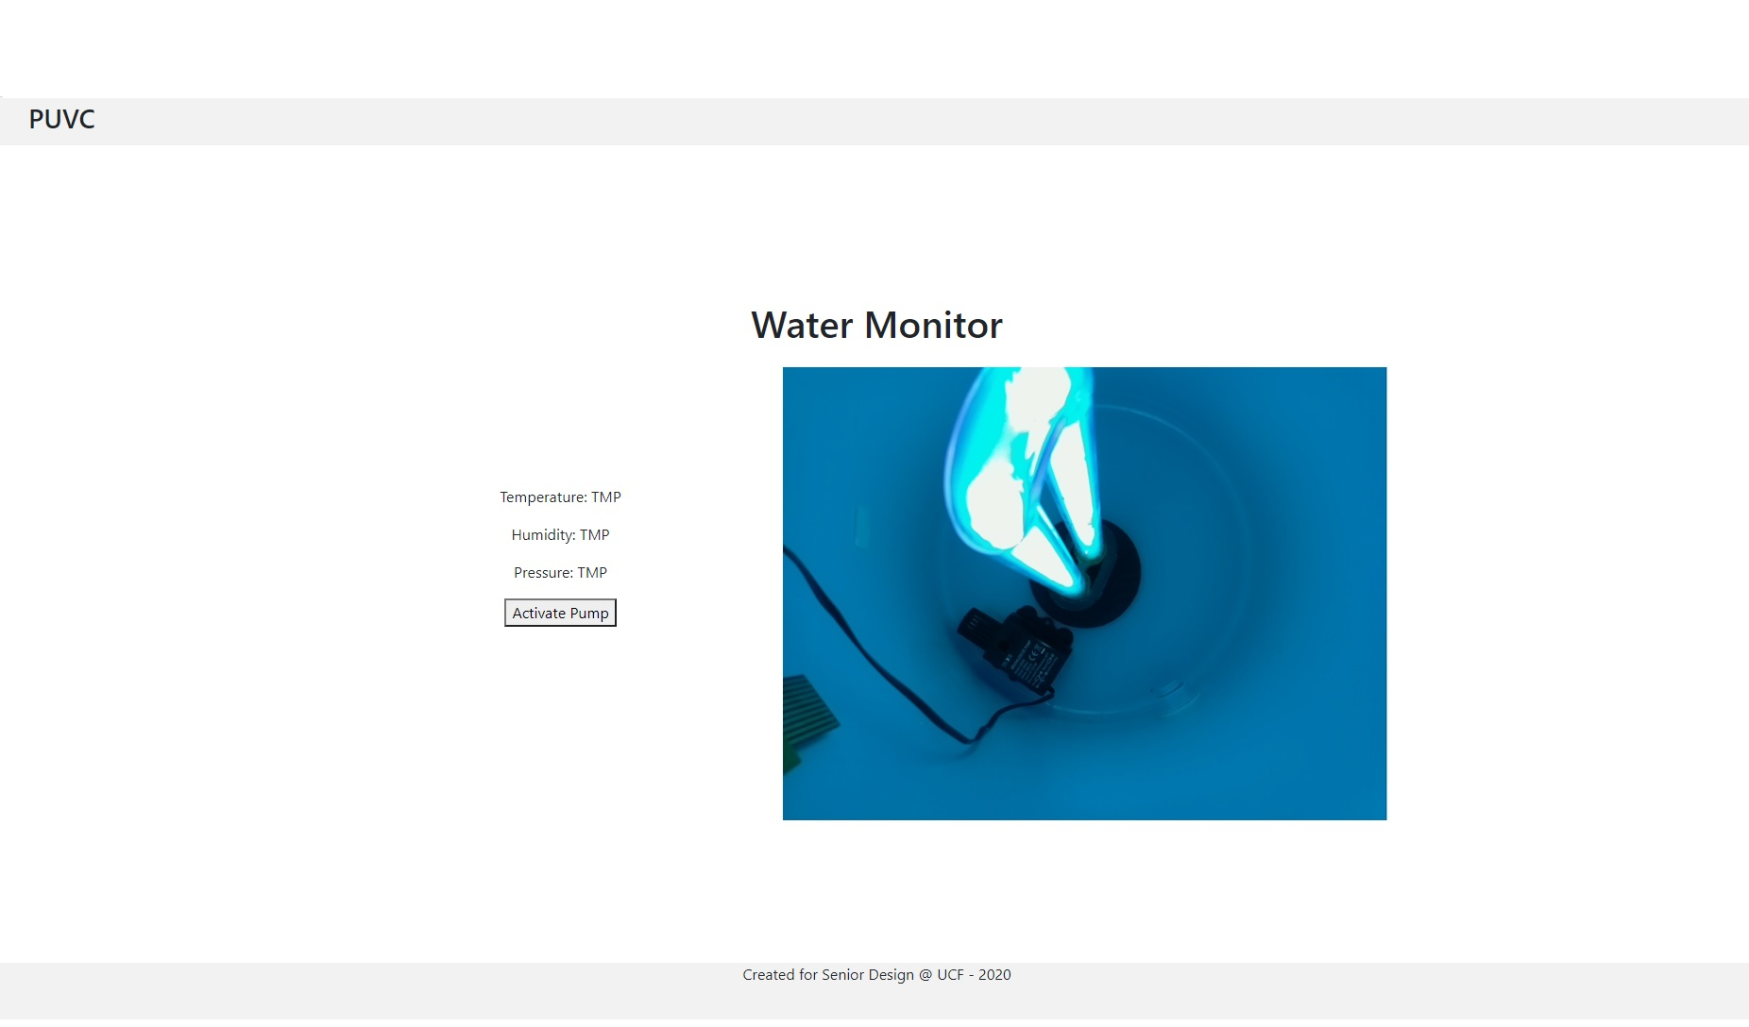
Fig. 11. Shown above is the UI with the UV lamp on.

The above figure(s) displays the basic UI to properly control and monitor the system. Showing environmental variables: temperatures, humidity, and pressure for the user to maintain a stable state. The UI also contains the button to activate the pump(s) and draw water into the tank, flowing it first through the UV LED array and then finally into the tank. Another button will be added to draw water out of the tank and into the verification tank which will be discussed in the following section. The camera (arducam) monitors the inside of the system, which will be visible specifically when the system is running, cleaning the water using the UV lamp.

VI. Water Quality Analysis Module
The water quality analysis module is the final stage of the PUVC. The analysis is performed by using a reagent based kit that produces a color change in the water sample. The color change can be determined by analysis with an RBG spectrum. Water is pumped from the main tank into the water analysis tank. The analysis tank is 100x100x150mm in size and holds 1350 mL of water to sample. There is a removable lid in the tank where the user can add the chemical reagent to the sample. The reagent works by accelerating growth of present coliform bacteria in the water. If coliforms are present they will rapidly multiply from the nutrients in the reagent. The test kit used in the demo is commercially available from The Clean Water Store for $29.99. This method was chosen because it is cheap and a simple method that requires no technical skills. Upon adding the reagent to the sample there is an immediate color change to an off yellow color. Over the next 24-48 hours the sample will turn blue-green if coliform bacteria is present. If coliform bacteria isn’t present the sample will remain yellow.
The process to verify the test results is fully automated aside from the initial balancing of the sensor. Inside the water quality analysis tank is a microchip, a RGB LED and a CdS photocell. To detect the color of the sample during analysis the RGB LED will pulse and illuminate the sample. Depending on the color of the sample, different proportions of the RGB spectrum will be transmitted, reflected and absorbed. The CdS photocell observes the reflected light. The photocell is a variable resistor whose resistance value changes based on the color of light impinged on the device. With no light the photocell has its peak resistivity. When light is shining, the material absorbs incoming photons causing electrons in the material to move from the valence band to the conduction band. Electrons in the conduction band have enough energy to move freely and thus the resistivity of the device is reduced. A cadmium sulfide photocell was chosen because its response curve is very similar to that of the human eye. The photocell is in series with a 10kΩ resistor forming a voltage divider. An analog voltage measurement is taken between the photocell and resistor. The voltage between the two resistors is interpreted by the software on the microchip to determine the color of the sample.
Before the sensor can be used to detect colors, it must be balanced. To balance the sensor it is shown a white background. The RGB LED is pulsed and the reflected light observed by the photocell. The process is then repeated for a black background. These measurements are then stored in an array. The RGB values in the black array are subtracted from the RGB values in the white array to form a differential array. The sensor then takes measurements from the water sample and creates a color array. The final color array is calculated by formula 2.

colorArray = (mesColorArray - blackArray)$÷$((diffArray)*255) (2)

The RGB data from colorArray is exported from the microchip to the Raspberry Pi. The logic used to determine if the sample contains coliform bacteria is relatively simple. If the proportion of green light detected is greater than the proportion of red light detected the sample is positive for coliform bacteria, otherwise the sample is negative. These results are then exported to the UI interface that prints the results in the form of pass/fail. This logic was chosen based on the testing results of the sensor and its container. The sensor does not accurately determine the true color of the sample, however it consistently detects a pink color when the sample is negative and a green color when the sample is positive. The colors detected by the sample are shown in Fig. 12.

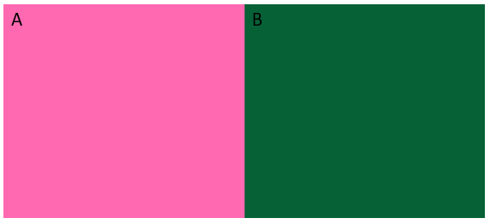
Fig. 12. (A) Sample negative for coliform bacteria (B) Sample positive for coliform bacteria

The main drawback for this method is the length of time required for the water to undergo color change from the reagent. The 24-48 hour timeline can be reduced to close to 24 hours by keeping the temperature of the water at 32-38 degrees celsius, but ultimately complicates the design of the water quality analysis tank. Instead standards were developed based on existing EPA standards for coliform bacteria detection in municipal water treatment centers and private wells. Water quality analysis post UV cleaning should be performed every time the PUVC is filled from a new water source. If the water source has been used previously to fill the PUVC, the most recent water quality analysis test must have been within 30 days to safely reuse the source without needing to test it again. If the test is positive for coliform bacteria 1mL of bleach should be added to the sample and the sample should be agitated and then disposed of while wearing personal protective equipment such as latex gloves. 5mL of bleach should be added to the main tank and left to sit for 24 hours. The entire tank should be emptied and cleaned thoroughly with bleach and warm water. If the same source tests positive a second time, the process for sanitizing the PUVC should be repeated and the user should cease use of the source all together. These standards were developed first and foremost to keep the user safe, but also to make the water quality verification process more convenient by not requiring the user to wait as much as 48 hours for every batch of water they need for use.
VII. Conclusion
In conclusion all the aforementioned devices composing the PUVC will ensure not only that the water receives a very high dose of UVC capable of killing most common pathogens and coliforms but also will allow the user will be able to control the device with a connected UI capable of active monitoring and informing the user whether or not the UV sanitation was successful.

Acknowledgements
Firstly the authors would like to thank all the advising professors Dr. Samuel Richie , Dr. David Hagan and Dr. Lei Wei of senior design for their dedication to guiding the students during a pivotal and distressing time.

The authors wish to acknowledge as well the assistance and support of Dr. Rodrgio Amezcua Correa, Dr. Axel Schulzgen and the entire microstructured fiber and device team for their dedication to help the team through the process of designing.

We would also like to thank the companies such as Atlantic Ultraviolet, Edmund Optics, for their technical support and advising on the project.

The Authors would like to thank Richard Zotti of the CREOL manufacturing lab as well for lending his time, materials, and patience during his retirement to allow the team to complete a full build of the device.

Biography of Team Engineers


Joseph Wahlen is a 24-year old graduating Photonic Science Engineering student who is going on to pursue a Masters in Optics and Photonics at the University of Central Florida specializing in micro-structured fibers, fiber systems and directed energy applications.

Raymond Masciarella is a 25-year old graduating Photonic Science and Engineering student. Who is pursuing full time employment in engineering with interest in optical fibers and communications. Currently employed as a trustee on the board of directors at The Bradford Ingalls Charitable Foundation.

Sannidiyan Rajendran is a 22-year old graduating Computer Engineering Student. He is planning to go into the Software Engineering industry with a focus in backend development.


Damian LaRocque is a 21-year old graduating Electrical Engineering student who is currently pursuing autonomous and control systems as well as embedded systems in the defense industry.

References
[1] Masschelein, W. J., Dr. (2002). Ultraviolet Light in Water and Wastewater Sanitation. BocaRaton, FL : Lewis.doi:https://books.google.com/books
[2] W. H. Cantrell, and W. A. Davis, “Amplitude modulator utilizing a high-Q class-E DC-DC converter,” 2003 IEEE MTT-S Int. Microwave Symp. Dig., vol. 3, pp. 1721-1724, June 2003.
[3] Downes A, Blunt TP. The influence of light upon development of bacteria. Nature 1877;16:218.
[4] Congreve, D. N., Lee, J., Thompson, N. J., Hontz, E., Yost, S. R., Reusswig, P., . . . Baldo, M. A. (2013, April 19). External Quantum Efficiency Above 100% in a Singlet-Exciton-Fission–Based Organic Photovoltaic Cell [Scholarly project]. Retrieved from https://science.sciencemag.org/content/340/6130/334/tab-article-info
[5] Zhang, S., Ye, C., Lin, H., Lv, L., & Yu, X. (n.d.). Uv Disinfection Induces a Vbnc State in Escherichia coli and Pseudomonas aeruginosa. Environmental Science & Technology.
[6] U. (2003). Ultraviolet Disinfection Guidance Manual. United States: Office of Water, National Service Center for Environmental Publications. doi:https://nepis.epa.gov
[7] McGrath, H Jr. “Ultraviolet-A1 irradiation therapy for systemic lupus erythematosus.” Lupus vol. 26,12 (2017): 1239-1251. doi:10.1177/0961203317707064

